State of Florida, Department of
Management Services
MyFloridaMarketPlace

Change Management Process Overview

Purpose
The purpose of this document is to provide an overview of the Application Change Management (Change Management) Process for the Florida eProcurement project. The audience for this document is all project team members who will participate in any aspect of Change Management Process.

Change Management allows the project management team to jointly manage changes that are not within the contractual scope of the eProcurement project. Rigorous change management increases the likelihood that the project will meet schedule, budget, and functional requirements.

Overview
DMS and Accenture have negotiated our contractual scope and base-lined our project plan. Now, DMS and Accenture must jointly control changes. We realize that changes made at any step in the development life cycle can have major impact on system design and project scope so we manage them carefully.

Whether major or minor, we treat all changes in the same manner. Even though minor changes typically take little time or effort to implement, allowing too many to go through uncontrolled can affect project timelines and system design. Major changes, by definition, are likely to require significant effort to implement, and therefore have impact on project timelines and system design. Since sweeping design changes and cost and schedule overruns are undesirable, we control all changes no matter how minor.

The figure below illustrates the processes surrounding our Change Management Process. Change Management can be invoked through three key business functional areas:
- PMO Office (New Issue or Risk)
- Integrated Customer Service (Escalated Service Incidents)
- Application Support (Design Reviews or Test Execution)

Figure 1. Change Management Overview
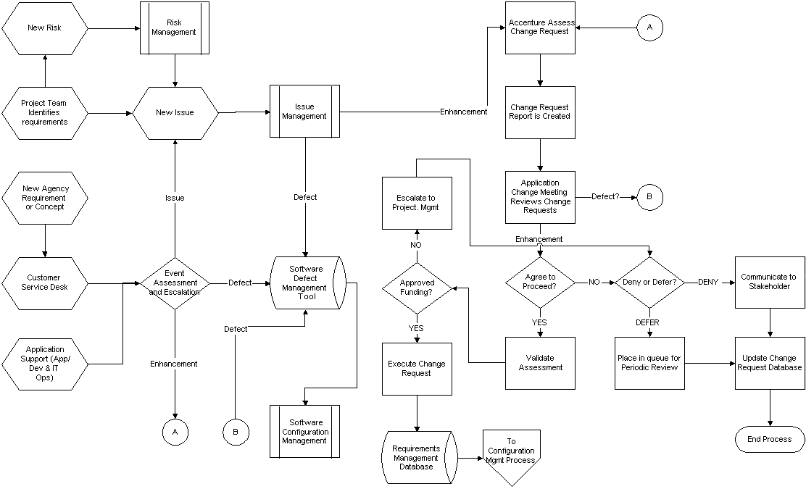

Our Change Management Process:

Our team is familiar with many of the drivers that cause change to occur and we take steps to deal with them before problems arise. Changes may be initiated by the following:
- Legislative changes or mandates
- Identification of new requirements (business process or technical interface changes)
- Issue resolution results

Our change control approach is collaborative. This means that all project team members, including the third party vendor, have input into the process. All change requests will be captured in our automated program management tool using the input form illustrated in Attachment A.

The figure below is a detailed illustration of the Change Management process depicted in overview the drawing on the previous page. Our process involves several steps that are described below.

Process for Initiation

Any person involved in the project effort, such as DMS staff, Accenture team member, or end users, can initiate a change request. A change request provides a description of the requested change and specifies the reason(s) for a change. Possible reasons include the discovery of a new requirement, the need to accommodate changing business processes, or a suggestion for general improvement. The originator then forwards the completed change request to their team lead. New ideas identified by the user community will be submitted to the customer service desk where a service ticket will be created. Any of our MyFloridaMarketPlace teams (i.e., Buyer Adoption, Vendor Management, Sourcing Services etc...) may identify new requirements and entered them either as a new Risk or new Issue.

Process for Evaluation, Including Any Impacts to Cost, Schedule

If the requested change has the potential for an impact on deliverables or the project plan, we require a full impact evaluation. The team lead assigns the change request to an analyst for evaluation and recommendation for action.

A detailed cost and scope analysis is accomplished once the need for the change request is validated. This analysis includes the hours required to accomplish the task (to include: design, develop, test, migrate the solution into production, and modify applicable support/training material), and the cost accomplish this level of effort based the rate structure outlined in Attachment “G” of MyFloridaMarketPlace procurement contract.

Process for Review and Approval
If the evaluation shows the change is justified, the team lead escalates the change request to the Project Management Team for further review. The Project Management Team review can result in either denying the request or escalating it to the MyFloridaMarketPlace Program Executive Leadership Team. The Program Executive Team will approve all changes that affect the cost and schedule of the MyFloridaMarketPlace engagement. A notification is sent to all impacted parties by the Project Management Team immediately following this decision.

When a change request is denied, any impacted parties are notified by the team lead and the change request is closed. In rare cases, change requests denied at this point may be reconsidered with new or additional information that may facilitate their approval at a later time.

Process for Implementation and Verification, Including Documentation Updates

After the PMO approves a change request, we assign a team member to implement it. Through the team lead, we take the actions approved by the change request are taken and that any consequential effect(s) of the change are identified and controlled.

We recognize that approving a change does not mean it has no impact. To lessen the impact of the implementation of approved changes, the team lead batches approved changes into regularly scheduled releases. Managing the release of new capability to the production system provides several benefits:
- End users receive a stable environment that changes only at regular intervals
- Training can include a number of upcoming changes vs. one off training occurring frequently
- Communication and training activities surrounding the release become routine and are planned in such a way as to not interrupt the valuable time of the end users
- The risk associated with a change are reduced when they are batched into a release vs. applied and tested in a one off fashion

Most changes will be released during regularly scheduled intervals. In rare cases, based on the impact of applying a change, changes will be applied outside the regularly scheduled release plan. In these cases, the change will significantly improve processing of the eProcurement system in such a way that it is mutually agreed that the change should be applied as quickly as possible.

The team lead is also responsible for verifying and closing the change request and supporting documentation as well as making sure the action(s) taken to implement the approved change are adequately documented.

Process for Tracking and for Change Documentation Retention

In order to effectively track change requests and retain any documentation supporting those requests, our team uses an automated tracking tool. This tool takes advantage of numerous completed projects and includes customization for the eProcurement project.

