PROJECT CHARTER

*<pROJECT nAME>*

*<Agency nAME>*

*<Date>*

Contacts

|  |  |  |  |
| --- | --- | --- | --- |
| **Agency Project Manager:** | | **Agency Project Sponsor:** | |
|  | |  | |
| **Phone:** |  | **Phone:** |  |
| **Email:** |  | **Email:** |  |

[NOTE TO THE AUTHOR]

*[The Project Charter formally communicates the existence of the project; serves as the basis for detailed planning; appoints the project manager; identifies the stakeholder and the project governance framework; authorizes the expenditure of resources; establishes the initial budget, schedule and scope.*

*This template is provided as a guideline – it is not mandated for any project, but may be used by any project. This template provides an overview of the standard content regarded as best practice for most projects. Project Managers should consult their governance authorities and Risk & Complexity Category to determine what specific information is required for the project. If an agency elects to use this template, it may be tailored, customized, and detailed to meet the needs and complexity of the project.*

The template includes instructions to the author, boilerplate text, and fields that should be replaced with the values specific to the project.

* *Blue italicized text enclosed in square brackets [text] provides instructions to the document author, or describes the intent, assumptions and context for content included in this document.*
* *Red text enclosed in angle brackets <text> indicates a field that should be replaced with information specific to a particular project.*
* *Text in black is provided as boilerplate examples of wording and formats that may be used or modified as appropriate to a specific project. These are offered only as suggestions to assist in developing project documents and are not mandatory.*

*When using this template, it is recommended that you follow these steps:*

* *Replace all text enclosed in angle brackets (e.g., <Project Name>) with the correct values.*
* *To add or remove sections of the document, ensure that the appropriate header, body text styles, and section numbering schemes are maintained.*
* *To update the Table of Contents, right-click and select “Update field” and choose the option- “Update entire table”*
* *Before submission of the first draft of this document, delete this “Notes to the Author” page and all instructions to the author, which appear throughout the document as blue italicized text enclosed in square brackets.]*

TABLE OF CONTENTS

1.0 EXECUTIVE SUMMARY 4

2.0 BUSINESS NEED AND OBJECTIVES 4

2.1 Business Need and Justification 4

2.2 Business Objectives 4

3.0 PROJECT SUMMARY 4

3.1 Project Description 4

3.2 Scope 4

3.3 Assumptions and Constraints 4

4.0 INITIAL PROJECT PLAN 4

4.1 Estimated Resource Requirements 5

4.2 Estimated Budget 5

4.3 Funding Source(s) 5

4.4 Procurement Strategy 5

4.5 Project Schedule Estimate 5

5.0 PROJECT AUTHORITY 5

5.1 Project Sponsor(s) 5

5.2 Project Manager 5

5.3 Project Stakeholders 6

5.4 Project Organizational and Governance Structure 6

6.0 PROJECT RISKS 6

6.1 Risk and Complexity Category 6

6.2 Initial Project Risks 6

7.0 PROJECT APPROVALS 7

# EXECUTIVE SUMMARY

# BUSINESS NEED AND OBJECTIVES

## Business Need and Justification

*[Provide a high-level summary of the business need and benefits for the project. Include a discussion of state or federal legislation or other project mandates. Discuss any cost factors (ROI, cost savings, cost avoidance, etc.) applicable to the project. If a separate Business Case or Cost Benefit Analysis has been prepared, you may incorporate it here by reference instead of repeating content.]*

## Business Objectives

*[Describe the business objectives of the project.]*

# PROJECT SUMMARY

## Project Description

*[Provide a summary of the project. Include all major project activities required to meet the business objectives and provide the business benefits.]*

## Scope

*[Project scope defines the work to be included (in scope), as well as the work not included (out of scope). Identify the project’s scope and any specific items identified as out of scope.]*

## Assumptions and Constraints

*[Provide any assumptions or constraints affecting project estimates.]*

# INITIAL PROJECT PLAN

*[It is recognized that planning is an iterative process that becomes increasingly precise as more detailed information becomes available.]*

## Estimated Resource Requirements

*[Estimate the types and quantities of resources required to perform the in scope work.]*

## Estimated Budget

*[Estimate the cost of resources (human, hardware, software, other products and services) to perform the in scope work.*

*Specify total project budget and budget breakout by Fiscal Year. Provide any detailed estimates available (budget categories, maintenance costs, etc.). Provide a basis or assumption / constraints for the estimated budget.]*

## Funding Source(s)

*[Specify funding source(s) for the project. If Grant funds will be used, include specifics such as grant title, number, amount, percent match, and period.]*

## Procurement Strategy

*[Provide an overview of any procurements expected for the project along with the procurement methods to be used.]*

## Project Schedule Estimate

*[Provide estimated level of effort (in hours) for the project as well as planned start and finish dates. Identify any known time constraints, such as implementation dates set in law, funding deadlines, etc. Provide the basis and assumptions for this estimate.*

*As known at this point in the project, provide an estimated schedule of high-level project phase gates, milestones, deliverables, and major decision points. It is understood that this is an estimate and will change as the project progresses and the tasks, milestones, and deliverables are elaborated.]*

# PROJECT AUTHORITY

*[This section describes the authority of the individual or organization initiating the project, limitations or initial checkpoint of the authorization, management oversight of the project and the authority of the project manager.]*

## Project Sponsor(s)

*[Identify the project sponsor(s) by name and title and specify that the individual has the authority to apply project* [*resources*](http://www.pmconnection.com/modules.php?name=Encyclopedia&op=content&tid=329)*, expend funds, make decisions and give approvals.]*

## Project Manager

*[Identify the project manager by name and define the individual’s level of authority. For example, the project manager may assign resources in a matrix organization, authorize overtime, conduct staff performance appraisals, and take appropriate corrective actions that do not increase schedule or cost.]*

## Project Stakeholders

*[Describe internal and external project stakeholders (individuals or groups). Include the expected level of impact on the project and the level of participation in the project (SME, oversight, etc.).]*

## Project Organizational and Governance Structure

*[Describe or depict the project’s organizational and governance structure. As known, identify groups or individuals (including stakeholders) that will be included in the project and describe their roles and responsibilities. Include roles within the project governance structure (such as Project Sponsor, Project Manager, Project Steering Committee, Agency Management, key stakeholders, etc.) and specify the authority for decision making and guidance.*

Example: Project Organizational & Governance Chart]

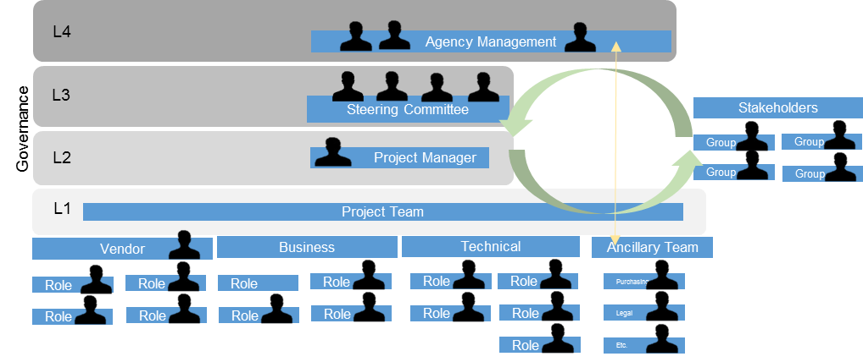

# PROJECT RISKS

## Risk and Complexity Category

*[Provide the Risk and Complexity Category for the project (from the Pre-Charter Risk and Complexity Assessment).]*

## Initial Project Risks

*[Provide an initial list of high-level risks that apply to this project.]*

# PROJECT APPROVALS

The undersigned acknowledge they have reviewed the *<Project Name>* **Charter** and agree with the information contained herein. The undersigned hereby give the project manager the authority to apply the approved level of organizational resources to project activities. Changes to this **Project Charter** will be coordinated with and approved by the undersigned or their designated representatives.

*[List the individuals whose signatures are desired. Examples of such individuals are Project Sponsor, Project Manager, Business Owner, IT Manager, or other Agency Management. Add additional lines for signature as necessary.]*

|  |  |  |  |
| --- | --- | --- | --- |
| Signature: |  | Date: |  |
| Print Name: |  |  |  |
| Title: |  |  |  |
| Agency: |  |  |  |
| Role: |  |  |  |
|  |  |  |  |
|  |  |  |  |
| Signature: |  | Date: |  |
| Print Name: |  |  |  |
| Title: |  |  |  |
| Agency: |  |  |  |
| Role: |  |  |  |

|  |  |  |  |
| --- | --- | --- | --- |
|  |  |  |  |
|  |  |  |  |
| Signature: |  | Date: |  |
| Print Name: |  |  |  |
| Title: |  |  |  |
| Agency: |  |  |  |
| Role: |  |  |  |
|  |  |  |  |
|  |  |  |  |
| Signature: |  | Date: |  |
| Print Name: |  |  |  |
| Title: |  |  |  |
| Agency: |  |  |  |
| Role: |  |  |  |